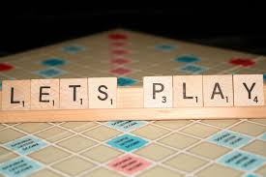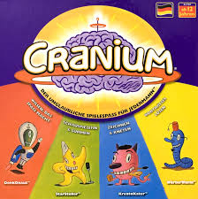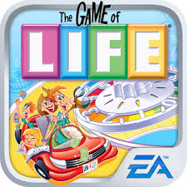

“O’Connell’s Got Game”
Welcome to O’Connell’s first Spring Spirit Week. It is going to be filled with games and fun for everyone! There will be a theme daily and a special activity for the students!
Theme | Daily Attire | Activities
Candy Land Monday | Sweet Dreams PJ Day | Ice Cream Social
Scrabble Tuesday  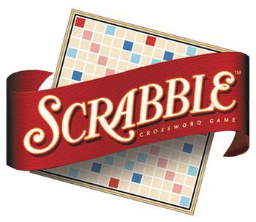 | Dress up as something that starts with the same letter as your name or wear the first letter of your name and make words with friends.  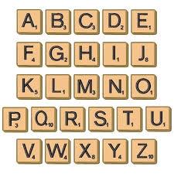 | Saidat Presentation  A feel good presentation and workshop for the students.
Battleship Wednesday  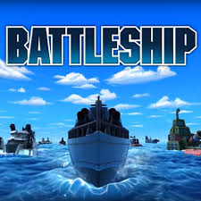 | Dress as your favorite superhero who fights battles!! | Battleship Lunch  Classes will battle each other with a tug of war!
The Game of Life Thursday  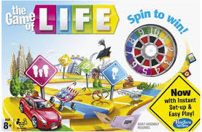 | Dress as your future career | Student Sock Hop

